

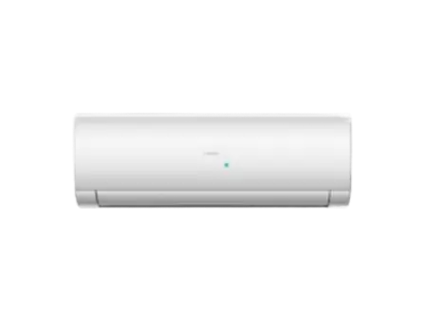

# Haier HSU 12HFCS W Heat

• Capacity (Ton) 1 Ton

• Cooling Capacity (BTU) 19000

• Inverter Yes

• Type Wall Mounted